To: Interested Parties
From: Morning Consult
Date: March 1, 2017
Subject: 22,000+ voter study shows Trump immigration ban wording can affect public opinion

Motivation:

Polls have shown varying levels of public support for the travel ban that President Trump announced in late January 2017. This variation likely stems from differences in question wording, how pollsters obtain their sample, and whether interviews are conducted online or by phone.

Morning Consult honed in on the impact of question wording asking more than 20,000 registered voters (22,278 to be exact) from February 10-27, 2017, about the travel ban by varying the action (e.g., block or ban), the length of the action (e.g., temporary of not), the population affected by the ban (e.g., people in general, or lawful U.S. residents as well) and how the countries affected by the ban were described (e.g., certain countries, countries with links to terrorism).

Overall, support for the ban is relatively high and does not change much over the two-week survey field period. Our main finding is that describing the type of people affected by the ban as “people, including U.S. lawful permanent residents and visa holders originally” rather than simply “people” reduces approval by four percentage points. By contrast, describing the action as a ban or block, as temporary or not, or varying how the seven countries are depicted does not affect public opinion. While question wording matters, our study suggests that whether people are interviewed online or by phone, and how the interviews are collected, explain much of the differences across polls.

What we did:
Morning Consult interviewed 22,278 registered voters nationally and varied the action (e.g., block or ban), the population affected (e.g., people, or lawful U.S. residents as well) and how the countries were described (e.g., certain countries, countries with links to terrorism). For example, respondents could view the following question: “Do you approve or disapprove of President Trump’s executive order [banning] [people] from [seven Muslim majority countries] and all refugees for 120 days from entering the United States?” where we vary the content in the three sets of brackets. In total, respondents saw one of 96 possible travel ban question combinations. The full list of combinations appears at the end of this document. The survey also included a series of demographic and policy tracking questions.

Results:
Overall, 54 percent of registered voters approved the executive order, 40 percent disapproved the executive order, and 6 percent did not have an opinion either way. Approval is 20 percentage points higher among seniors (58%) than among adults under 30 years old (39%), Republicans (85%) are three times as likely to approve as Democrats (29%), and men (59%) are 10 percentage points more likely to approve than women (49%).

Voters living in the South and Mountain West are most likely to approve the ban. In these states, 60% or more of registered voters approve the ban. By contrast, approval for the ban in California and in the Northeast is around 40%. See the map below for state-level results using multi-level regression and post-stratification (MRP).

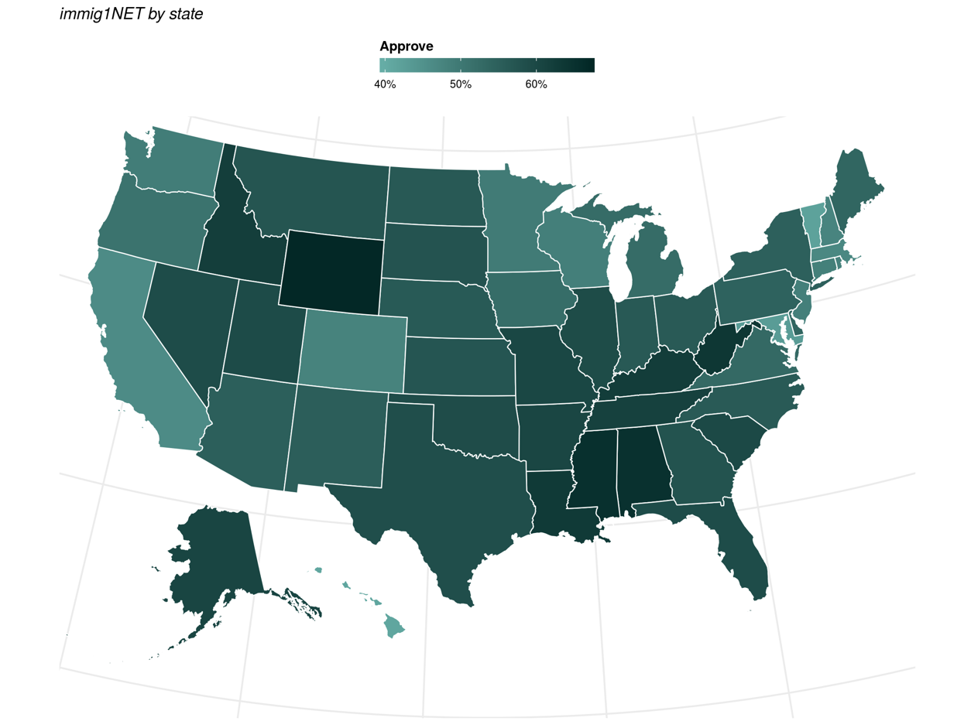

Approval relatively stable over time
- Day to day results are quite stable, with 53% approval at the beginning (February 10-11) and end (February 26-27) of the data collection period. Over the 18 days we tracked this question, approval ranged from 51 to 57 percent of registered voters and disapproval ranges from 37 to 43 percent

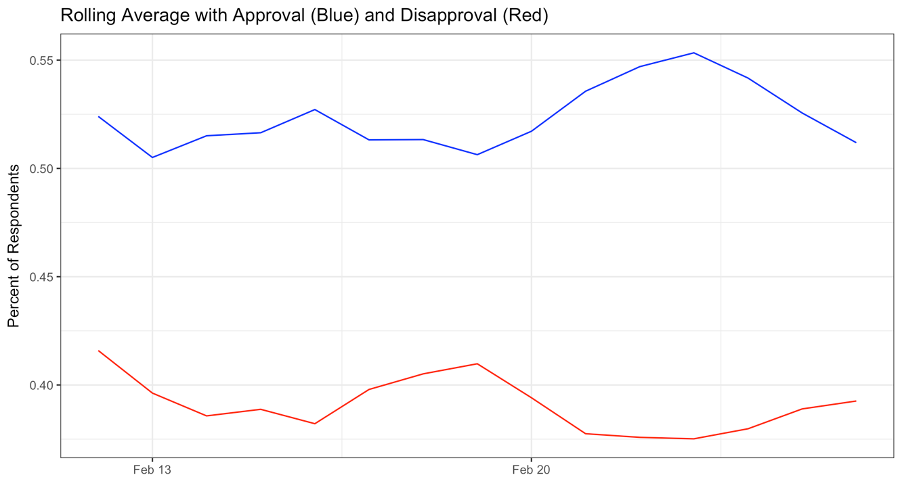

 | Approve | Disapprove | DK
2/11/17 | 0.52 | 0.42 | 0.06
2/12/17 | 0.53 | 0.42 | 0.05
2/13/17 | 0.53 | 0.41 | 0.07
2/14/17 | 0.53 | 0.42 | 0.06
2/15/17 | 0.55 | 0.38 | 0.08
2/16/17 | 0.52 | 0.41 | 0.08
2/17/17 | 0.55 | 0.39 | 0.07
2/18/17 | 0.51 | 0.43 | 0.07
2/19/17 | 0.52 | 0.43 | 0.05
2/20/17 | 0.53 | 0.4 | 0.07
2/21/17 | 0.55 | 0.39 | 0.07
2/22/17 | 0.57 | 0.37 | 0.05
2/23/17 | 0.55 | 0.39 | 0.06
2/24/17 | 0.57 | 0.38 | 0.05
2/25/17 | 0.54 | 0.39 | 0.07
2/26/17 | 0.52 | 0.43 | 0.05
2/27/17 | 0.54 | 0.4 | 0.06
Population
- Support for the ban is four percentage points higher when the population is described as “people” rather than “people, including U.S. lawful permanent residents and visa holders originally”
  - People
    - Approve 55, Disapprove 39
  - People including U.S. lawful permanent residents and visa holders originally
    - Approve 51, Disapprove 42

Banning vs blocking
- There is no difference in results when respondents see the word banning (53 approve, 40 disapprove) versus blocking (54 approve, 40 disapprove).

Temporary or not
- There is no difference in responses when blocking/banning with no time limit (54 approve, 40 disapprove), the word ‘temporary’ (53 approve, 41 disapprove) or the phrase ‘for 90 days’ (54 approve, 40 disapprove) is used.

Country description
- The country description has relatively a limited impact on responses.
- Responses are similar when you describe the countries generally as when you include the names of the seven countries. For example, “seven countries linked to political instability and violence” receives similar levels of support as “seven countries linked to political instability and violence -- Iran, Iraq, Libya, Somalia, Sudan, Syria and Yemen”. The same goes for “seven countries linked to terrorism” and “seven Muslim majority countries.’

Bringing It All Together
On average, between 200 and 300 registered voters viewed each of the 96 combinations. Among the 10 combinations that garnered the highest approval, 9 of the top 10 combinations with the highest approval say “people” and 8 of the top 10 combinations with the highest approval have “blocking.”

 | Top 10 (of 96) Approve
Description of People
People | 9
People, including U.S. lawful permanent residents… | 1
Action
Banning | 2
Blocking | 8
Length of Action
Permanent | 3
Temporary | 3
90 days | 4
Description of Country
certain countries | 1
seven Muslim majority countries | 1
seven Muslim majority countries -- Iran, Iraq, Libya, Somalia, Sudan, Syria and Yemen | 0
seven countries linked to terrorism | 3
seven countries linked to terrorism-- Iran, Iraq, Libya, Somalia, Sudan, Syria and Yemen -- | 0
seven countries linked to political instability and violence | 2
seven countries linked to political instability and violence -- Iran, Iraq, Libya, Somalia, Sudan, Syria and Yemen -- | 2
Iran, Iraq, Libya, Somalia, Sudan, Syria and Yemen | 1

Question Stem
Do you approve or disapprove of President Trump’s executive order …

Clause 1 (action) – 6 versions

1. banning
2. temporarily banning
3. banning for 90 days
4. blocking
5. temporarily blocking
6. blocking for 90 days

Clause 2 (subject) - 2 versions

1. people [2/3rds sample]
2. people, including U.S. lawful permanent residents and visa holders originally [1/3rd sample]

from

Clause 3 (country) - 8 versions

1. seven Muslim majority countries
2. seven Muslim majority countries -- Iran, Iraq, Libya, Somalia, Sudan, Syria and Yemen --
3. Iran, Iraq, Libya, Somalia, Sudan, Syria and Yemen
4. certain countries
5. seven countries linked to terrorism
6. seven countries linked to terrorism-- Iran, Iraq, Libya, Somalia, Sudan, Syria and Yemen --
7. seven countries linked to political instability and violence
8. seven countries linked to political instability and violence -- Iran, Iraq, Libya, Somalia, Sudan, Syria and Yemen --

and all refugees for 120 days from entering the United States?

Here's a full example:
Do you approve or disapprove of President Trump’s executive order banning people from seven Muslim majority countries and all refugees for 120 days from entering the United States?

- Strongly Approve
- Somewhat Approve
- Somewhat Disapprove
- Strongly Disapprove
- Don't Know / No Opinion

